

***NAME: Sitara Rehman***

***Sap ID: 66454 BScs***

***Subject: Operating system Lab 05***

***Submitted to: Ma’am Ayesha Akram***

***Semester: 05***

***Task :01:***

Run all switches with uname command.

-r, -m, -p, -I, -o, -a, -v, -n

And define in one line about these commands according to your understanding

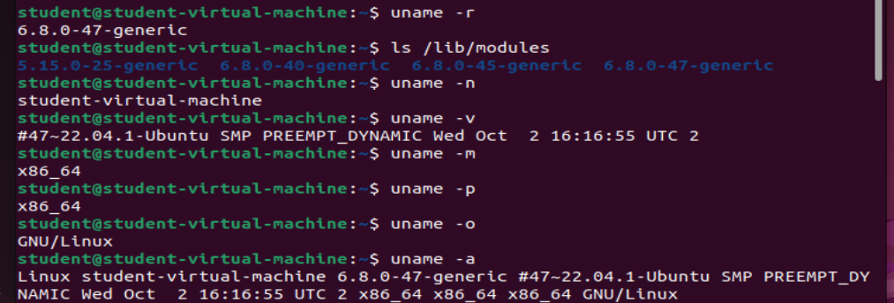

The **uname** command is used to check system information in Linux.

|  |  |  |
| --- | --- | --- |
| -r | Tells you the **kernel version** (the heart of your system). |  |
| -m | Shows what type of **computer** you're using (like 64-bit or 32-bit). |  |
| -p | Shows what type of **processor (CPU)** your computer has. |  |
| -i | Tells your **hardware platform** (basically same as -m). |  |
| -o | Shows what **Operating System** you're running. |  |
| -a | Shows **everything** at once (all the above info). |  |
| -v | Shows the **release date** of your kernel. |  |
| -n | Shows your **computer name** (hostname). |  |

***Task:2***

*Create new file named labSort and insert following text*

*End of file*

*6 apples*

*file to be sorted*

*apple on the table*

*23 years old*

*File To be Sorted*

*78 apples*

*Class*

*3 bananas*

*99 sort files*

***Solution:***

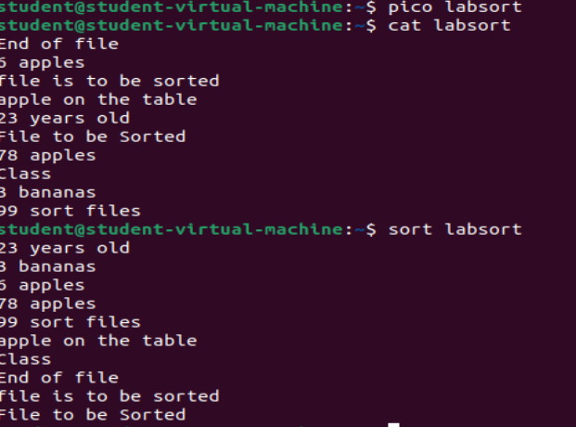

***Task:3***

Create another file with name SortLabNumeric two columns in it.

12 Online classes

6 Network security

14 Hacking stories

7 Tom and jerry

13 People of Pakistan

One column contains numeric values while other contain text. Now perform sorting on both columns. Also perform -n switch on both columns again and observe the pattern.

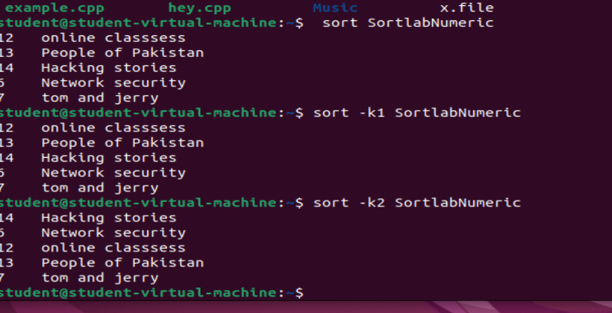

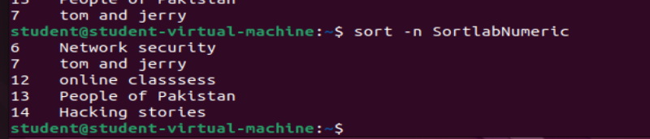

***Task:04***

The **cd** command is used to **move around folders** in Linux.

Here are its options in simple language:

| **Command** | **What It Does** | **Example** |
| --- | --- | --- |
| cd | Go to your **home folder** | Just type cd |
| cd folder name | Go inside a **folder** | cd Music |
| Cd .. | Go **back one folder** (Parent folder) | cd .. |
| cd ../ | Go **back two folders** | cd .../ |
| cd - | Go back to the **last folder** you were in | cd - |
| cd ~ | Go to **home folder** (same as cd) | cd ~ |
| cd / | Go to the **main folder** of your system (root folder) | cd / |
| cd -- | Go into folders that start with a **dash (-)** | cd -- |